Basic Switching Lab

1. Topology

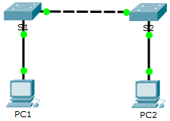

1. Configure SW1
   1. Examine the current switch configuration.
      1. Answer the following questions:
         1. How many FastEthernet interfaces does the switch have? 24 interfaces
         2. How many Gigabit Ethernet interfaces does the switch have? 2 Gigabit Ethernet
         3. What is the range of values shown for the vty lines? 0 to 15
         4. Which command will display the current contents of non-volatile random-access memory (NVRAM)?

_________________________________________show startup-config _______________________________________

1. Create a Basic Switch Configuration
   1. Assign a name to a switch.
   2. Secure access to the console line to IST452.

Why is the **login** command required?

__________________________________The login command is required to enable password authentication for a specific cisco device. _____________________________________________________

_______________________________________________________________________________________

* 1. Verify that console access is secured.

Exit privileged mode to verify that the console port password is in effect.

* 1. Secure privileged mode access.

Set the **enable** password to **452IST**.

* 1. Verify that privileged mode access is secure.
     1. Enter the **exit** command again to log out of the switch.
     2. Press **<Enter>** and you will now be asked for a password:
     3. The first password is the console password you configured for **line con 0**. Enter this password to return to user EXEC mode.
     4. Enter the command to access privileged mode.
     5. Enter the second password you configured to protect privileged EXEC mode.
     6. Verify your configurations by examining the contents of the running-configuration file:

Notice how the console and enable passwords are both in plain text. This could pose a security risk if someone is looking over your shoulder.

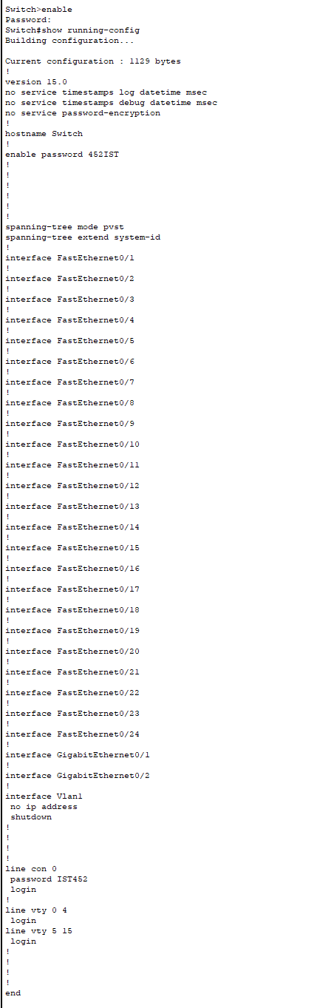

* 1. Configure an encrypted password to secure access to privileged mode.

The **enable password** should be replaced with the newer encrypted secret password using the **enable secret** command. Set the enable secret password to **itsasecret**.

**Note**: The **enable secret** password overrides the **enable** password. If both are configured on the switch, you must enter the **enable secret** password to enter privileged EXEC mode.

* 1. Verify that the enable secret password is added to the configuration file.
     1. What is displayed for the **enable secret** password? $1$mERr$ILwq/b7kc.7X/ejA4Aosn0
     2. Why is the **enable secret** password displayed differently from what we configured?

_________________________________________It is because it is encrypted. ___________________________________________

____________________________________________________________________________________

* 1. Encrypt the enable and console passwords.

As you noticed in Step 7, the **enable secret** password was encrypted, but the **enable** and **console** passwords were still in plain text.

Encrypt these plain text passwords.

If you configure any more passwords on the switch, will they be displayed in the configuration file as plain text or in encrypted form? Explain.

__________________They will all be displayed in encryption form. The “service password-encryption” encrypts all passwords in the configuration file using an encryption algorithm. _________________________________________________________________

_______________________________________________________________________________________

1. Configure a MOTD Banner
   1. Configure a message of the day (MOTD) banner.

The banner should read “This device is for IST 452 student access only”

* + - 1. When will this banner be displayed?

_____________________________It will be displayed when the user logs into the switch through console or a virtual terminal line ._______________________________________________________

____________________________________________________________________________________

* + - 1. Why should every switch have a MOTD banner?

______________________________It can be a useful tool to remind users of their obligations and responsibilities while logged in. ________________________________________

____________________________________________________________________________________

____________________________________________________________________________________

____________________________________________________________________________________

1. Save Configuration Files to NVRAM
   1. Verify that the configuration is accurate.
   2. Save the configuration file.

What is the shortest, abbreviated version of the **copy running-config startup-config** command?

copy run start

* 1. Examine the startup configuration file.

Which command will display the contents of NVRAM? show startup-config

Are all the changes that were entered recorded in the file? Yes

1. Configure S2

You have completed the configuration on S1. You will now configure S2. If you cannot remember the commands, refer to Parts 1 to 4 for assistance.

Configure S2 with the following parameters:

1. Name device: **S2**
2. Protect access to the console using the **IST452** password.
3. Configure an enable password of **452IST** and an enable secret password of **itsasecret**.
4. Configure a message to those logging into the switch with the same message from S1:
5. Encrypt all plain text passwords.
6. Ensure that the configuration is correct.
7. Save the configuration file to avoid loss if the switch is powered down.
8. Implementing Basic Connectivity

Addressing Table

|  |  |  |  |
| --- | --- | --- | --- |
| Device | Interface | IP Address | Subnet Mask |
| S1 | VLAN 1 | 148.43.10.220 | 255.255.255.128 |
| S2 | VLAN 1 | 148.43.10.225 | 255.255.255.128 |
| PC1 | NIC | 148.43.10.150 | 255.255.255.128 |
| PC2 | NIC | 148.43.10.175 | 255.255.255.128 |

1. Configure the PCs

Configure PC1 and PC2 with IP addresses.

* 1. Configure both PCs with IP addresses.
  2. Test connectivity to PCs.
     1. Click PC1. Close the **IP Configuration** window if it is still open. In the **Desktop** tab, click **Command Prompt**.
     2. Type the **ping** command and the IP address for PC2 and press Enter.

1. Configure the Switch Management Interface

Configure S1 and S2 with an IP address.

* 1. Configure S1 with an IP address.

Why do you enter the **no shutdown** command?

_____________________________The no shutdown command is used to activate or enable interface with the specified IP address. _________________________________________________________

_______________________________________________________________________________________

* 1. Configure S2 with an IP address.

Use the information in the Addressing Table to configure S2 with an IP address.

* 1. Verify the IP address configuration on S1 and S2.

Use the **show ip interface brief** command to display the IP address and status of all the switch ports and interfaces. You can also use the **show running-config** command.

* 1. Save configurations for S1 and S2 to NVRAM.

Which command is used to save the configuration file in RAM to NVRAM?

copy run start

_______________________________________________________________________________________

* 1. Verify network connectivity.

Network connectivity can be verified using the **ping** command. It is very important that connectivity exists throughout the network. Corrective action must be taken if there is a failure. Ping S1 and S2 from PC1 and PC2.

* + 1. Click PC1 and then click the **Desktop** tab.
    2. Click **Command Prompt**.
    3. Ping the IP address for PC2.
    4. Ping the IP address for S1.
    5. Ping the IP address for S2.

All pings should be successful. If your first ping result is 80%, try again. It should now be 100%. You will learn why a ping may sometimes fail the first time later in your studies. If you are unable to ping any of the devices, recheck your configuration for errors.